To deal with the previously mentioned challenges, we need the ability to load follow to prevent economic losses from excess energy being supplied to the grid when demand is low. Current nuclear reactors do not have this ability to ramp up or down electricity production fast enough being by consequence not able to load follow. On the other hand, renewables don’t have the efficiency nor capacity to supply energy to the entire population. To fix these issues, we propose a nuclear-renewable integrated energy system consisting in an advance nuclear reactor, specifically a molten salt reactor, coupled with a secondary industry process and a solar and wind farm. The molten salt reactor is a generation IV fission reactor and it is based on the molten salt reactor experiment carried in the 1960s at the oak ridge national laboratory. This class of reactors has many advantages compared to actual light water and boiling water reactors being the main one that it uses liquid molten fuel instead of solid fuel. This means no costly and dangerous pressurized systems and inherited passive safety (walk away safe) in the overall plant. For the secondary process there are many adequate choices that will depend on the thermal or electric requirements. Based in the fact that our reactor has an outlet temperature of around 700C we selected a four-step copper chloride hydrogen production process.

Since solar and wind are only cyclical throughout the day, meaning that they only work when there is sun and/or wind, they will supply all energy being produced to the electrical grid. The nuclear reactor will provide the other portion of the required electricity and the excess energy instead will be use to produce hydrogen. The hydrogen will be stored in pressurized tanks and sold in the market for a profit. All in together means that all the energy will be use in more intelligent and efficient manner. When demand peaks, the hydrogen production rate can be stopped or slowed and during lows the rate can be resume or increase. The overall system then becomes efficient and highly profitable but more importantly it solves the problem with nuclear  and renewables sources in an environmentally friendly way.

All members of the team will be working together in the design and integration of the individual technologies in a single system and work in the automatization of the overall grid/process. This will involve looking at the individual technologies and describing them in a detailed way to be able to interconnect them. This will be facilitated by the fact that the only design constraint is that the hydrogen plant needs to be directly coupled with the reactor. The solar and wind farms can be situated in different sites as long as they are connected to the same grid. An example of the system is portrayed in Figure X from the Idaho National Laboratory where the Nuclear energy sources is supplying electricity to the grid but also thermal energy to various secondary processes. In this example there is a thermal energy storage facility and different sources of solar energy.

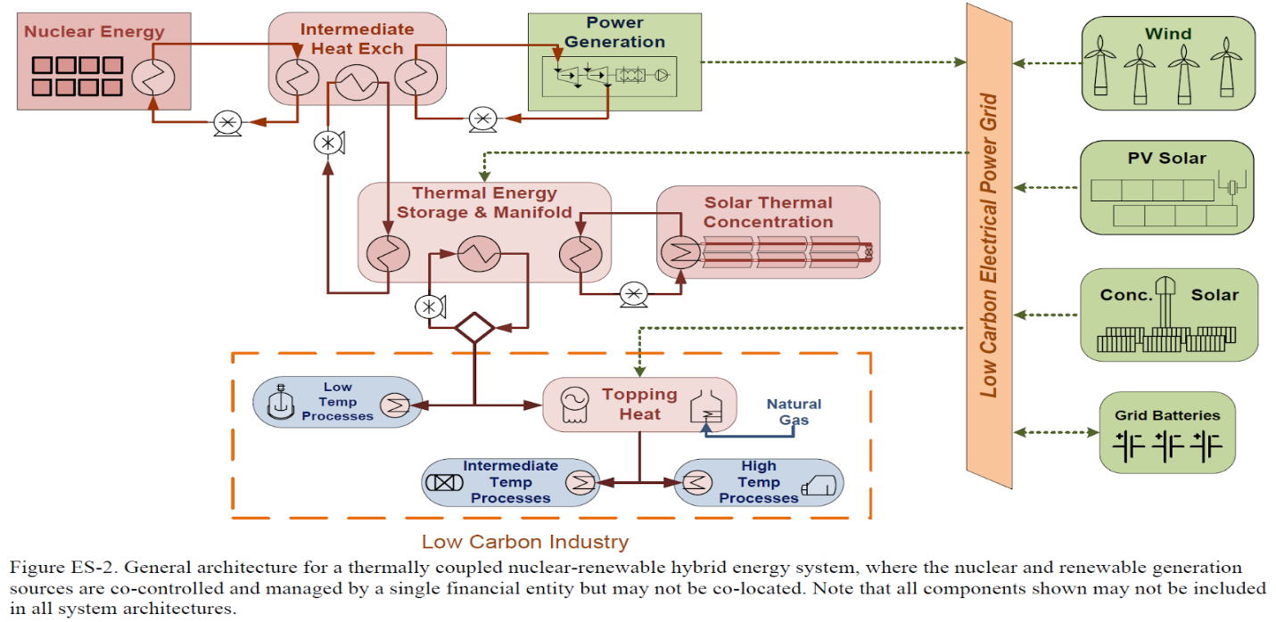

Figure 1. Nuclear-Renewables Integrated System from Idaho National Laboratory (Bragg-sitton et. al. 2016)

The first main challenge in the capstone project is the interconnection of the molten salt reactor and the hydrogen production plant. Once the system design is complete the next challenge is to find a way to automatize the whole grid to make it as efficient, economically and energetically, as possible. This means building an intelligent system capable of balancing the electricity output, from the nuclear reactor, and the hydrogen production rate depending on the grids demand and all this without the need of human operators intervention. The automatization design process will involve the modeling and simulation of different real life scenarios where energy demand varies during the day. The system should be able to adapt to these scenarios and run smoothly, safely and efficiently.